**ASSIGNMENT 2**

|  |  |
| --- | --- |
| Date | 28 september 2022 |
| Team id | PNT2022MID44881 |
| project name | Analytics for hospital health care data |
| Maximum marks | 2 marks |

***Challenges:***

***Upload the data set to cognos analytics,prepare the data,***

***explore and create .***

***1.C.sales by customer colored by customer***

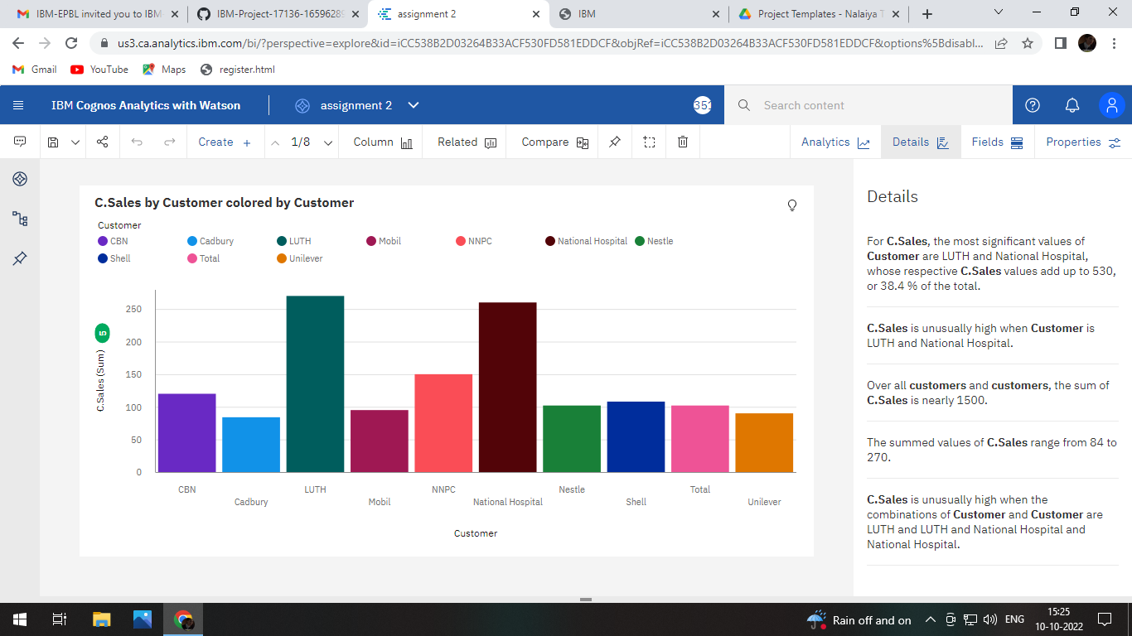

***2.Location for C.sales regions and location points***

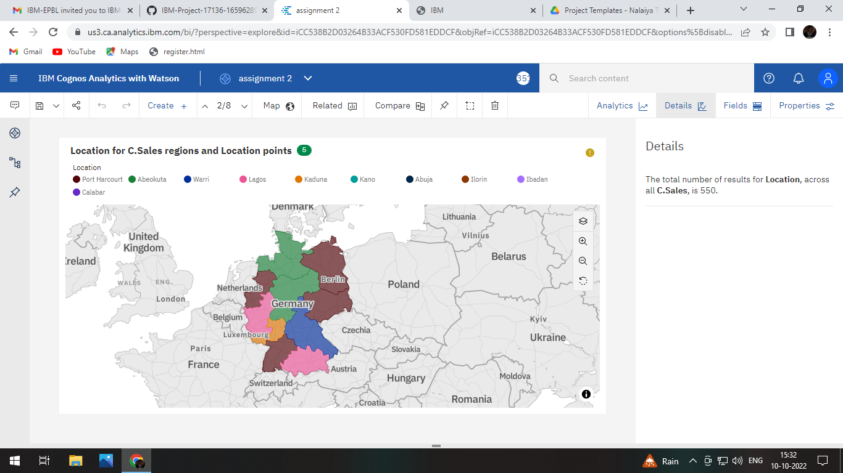

***3.C.Sales by sales rep***

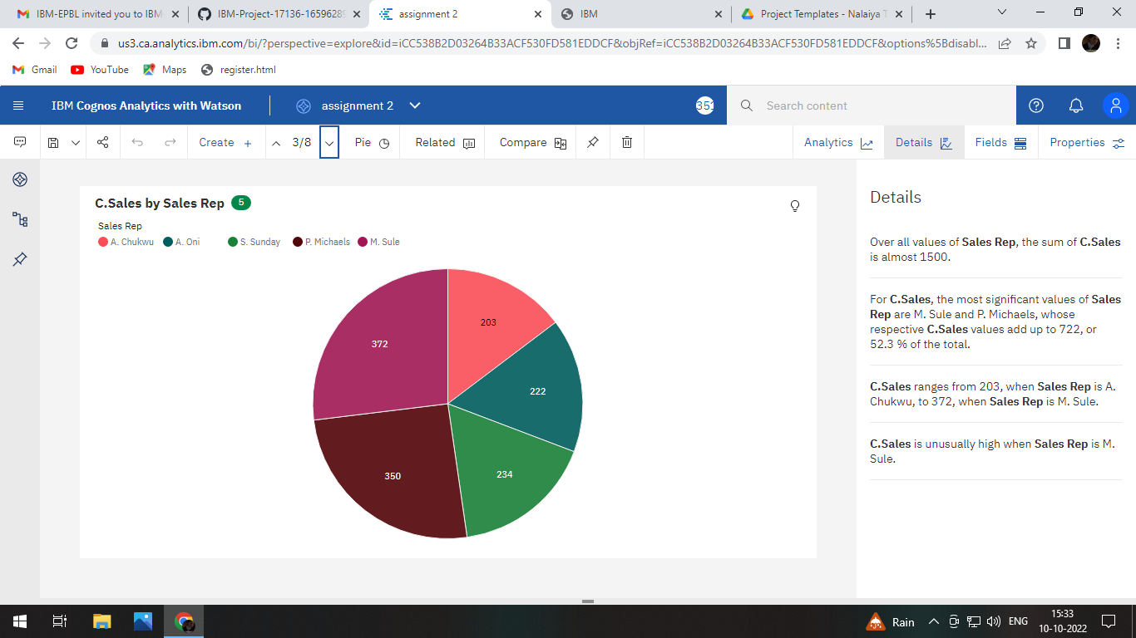

***4.Received Inventory by supplier colored by supplier***

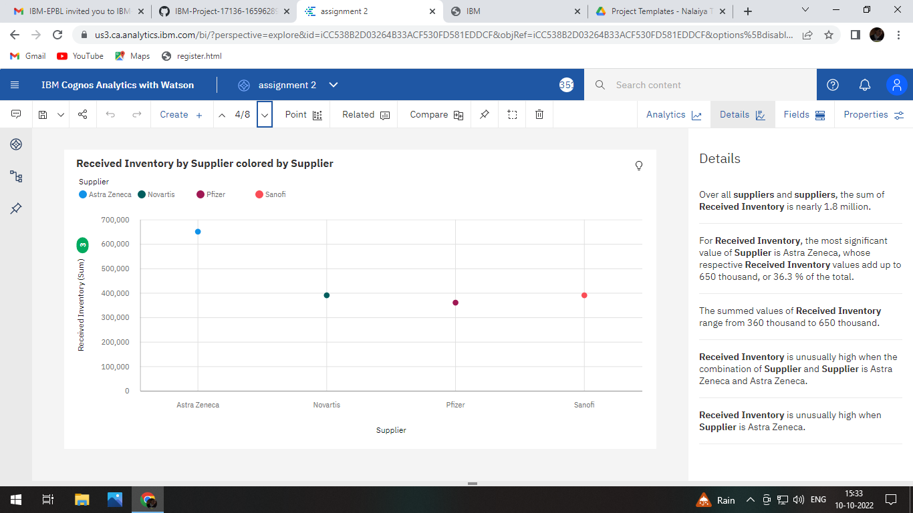

***5.Inventory stock for warehouse location region***

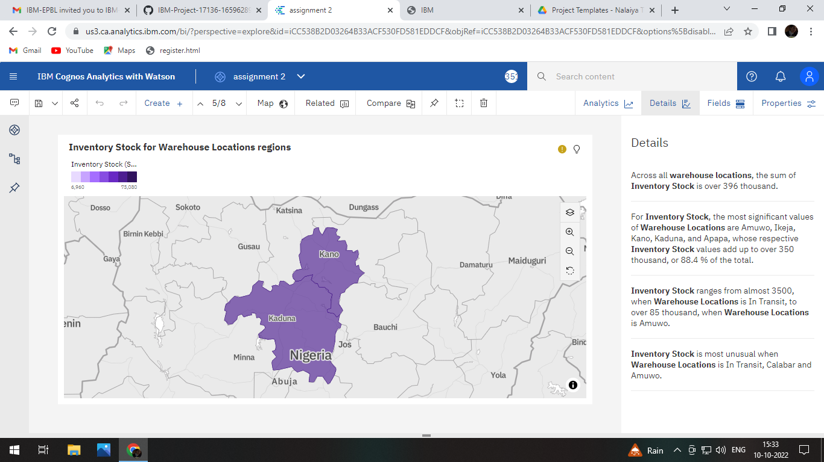

***6.Product compared to C.sales by C.sales and product colored by c.sales***

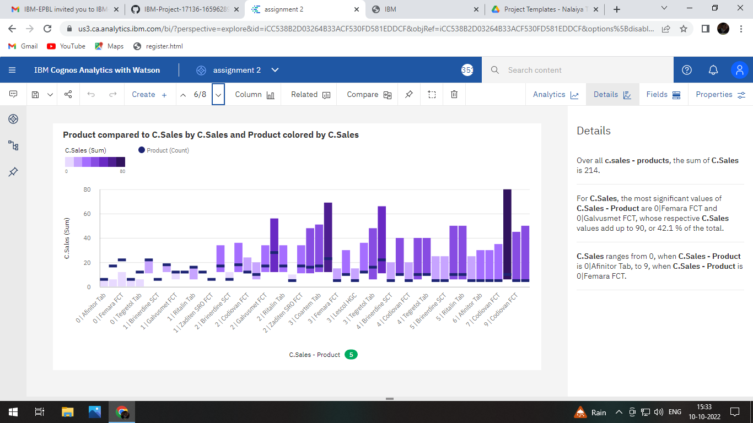

***7.C.sales by Month***

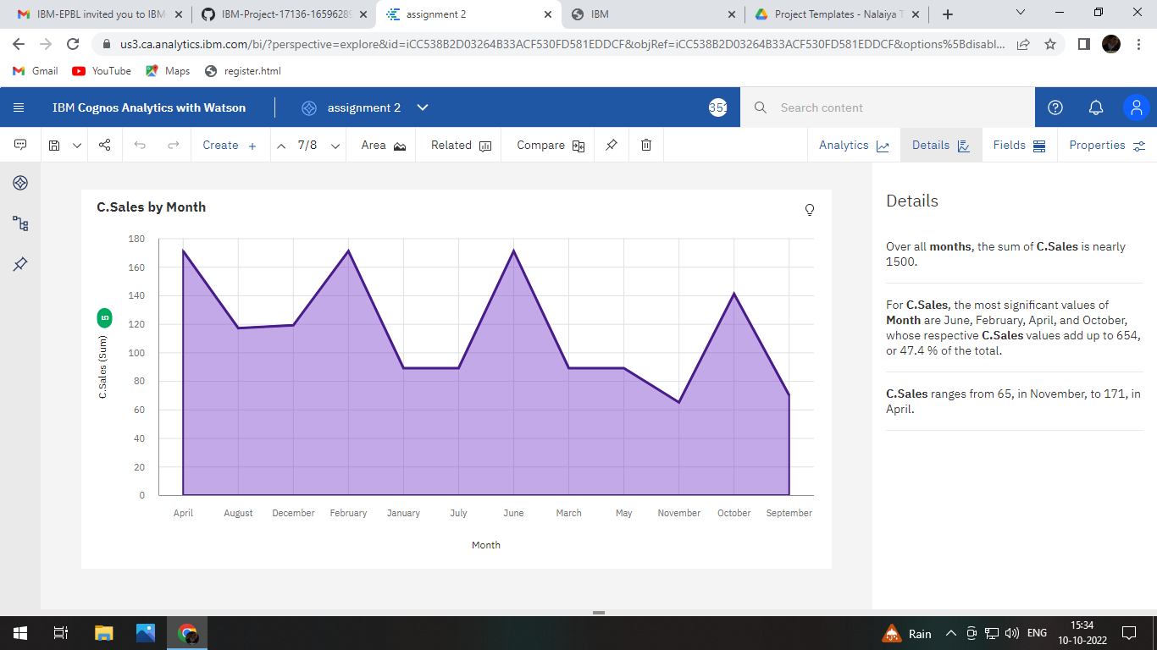

***8.Actual and received inventory by month***

